## Chloe Hei Yu Law

## 40173275

## Assignment 2. Project Schedule and Earned Value Analysis

**Description**

The purpose of this delivery is to get experience developing a schedule with a popular project management tool (Microsoft Project, or [Gantt Project](https://www.ganttproject.biz/#is-easy)) and understand the necessary elements required to design a successful schedule. You will learn what constitutes a software project task, how to organize tasks, how to monitor them as the project evolves.

In part 2, you will get experience using the Earned Value Analysis (EVA) approach to apply monitor and controlling techniques to track the progress on a project for a specified date.

### Part 1 Project Schedule

Given the following project plan

|  |  |  |  |  |
| --- | --- | --- | --- | --- |
| **ID** | **Task** | **Predecessor** | **Duration (days)** | **Budget ($)** |
| A | Background study | Start | 3 | 1,014.00 |
| B | Prototyping | A | 1 | 338.00 |
| C | Design | B | 15 | 5,070.00 |
| D | Development | C | 7 | 2,366.00 |
| E | Testing | C | 7 | 2,366.00 |
| F | System documentation | Start | 26 | 8,788.00 |
| G | Deploy system | D, E | 7 | 2,366.00 |
| H | Maintenance | D, E | 7 | 2,366.00 |

Table 1.

Tasks

1. Input the information from the table above and generate the Gantt Chart and include it in your report. Consider the **start of the project October 1st, 2022, and weekends as normal workdays.** 4 points.

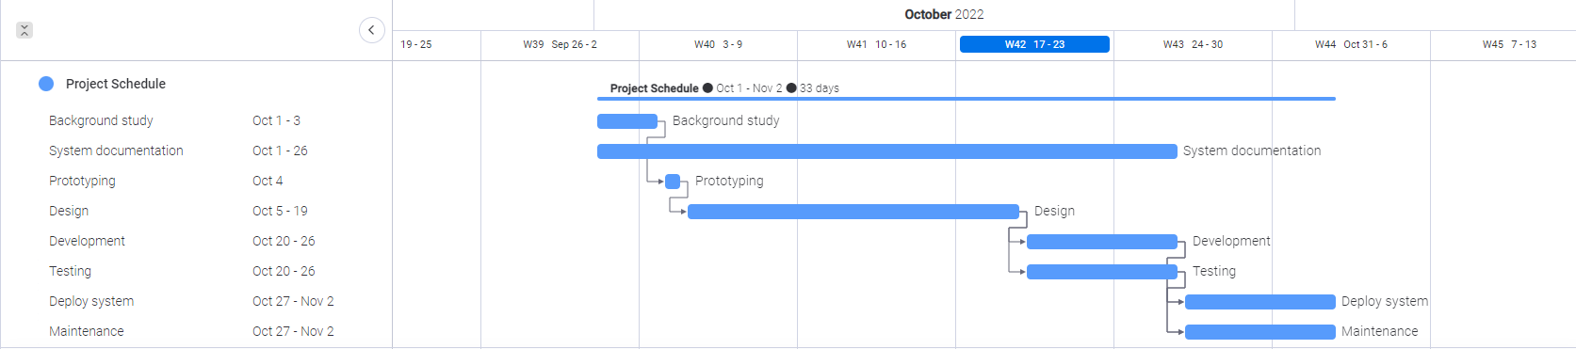

1. Convert the project into a Task Network Diagram. List the duration of all paths and identify the critical path. 4 points.

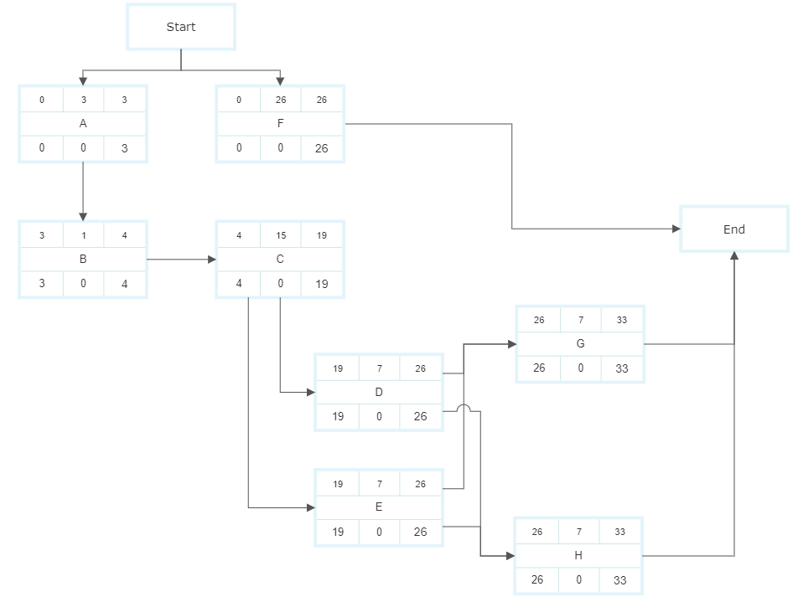

Start – A – B – C – D, E – G, H

Answer the following questions:

1. When is the end date for the project? 1 point.

November 2

1. What is the duration of the project? 1 point.

33 days

1. Suppose that the duration of activity C is shortened to 7 days. Calculate the end date for the project. 1 point**.**

October 26

1. What is the critical path now (list all paths with durations)? 1 point.

No critical path

Forget the scenario depicted in 5. Suppose that activity H duration is extended 8 days more.

1. What is the new end date for the project? 1 point.

November 3

1. What is the critical path (list all paths with durations)? 1 point.

Start – A – B – C – D, E – G, H

All dependencies are assumed to be FS - Finish to start.

Total part 1: 14 points

### Part 2 Earned Value Analysis

Given the following progress status shown in Table. Perform an analysis of the project status **on October 17th**, using EVA.

|  |  |  |  |  |  |
| --- | --- | --- | --- | --- | --- |
| **ID** | **Task** | **Status %** | **Actual start** | **Actual Duration (days)** | **Actual costs ($)** |
| A | Background study | 100 |  |  | 1050 |
| B | Prototyping | 100 | +3 days | + 1 day | 700 |
| C | Design | 50 |  |  | 3000 |
| D | Development | 0 |  |  | ? |
| E | Testing | 0 |  |  | ? |
| F | System documentation | 38.5 |  |  | 3400 |
| G | Deploy system | 0 | ? | ? | ? |
| H | Maintenance | 0 | ? | ? | ? |

Table 2.

**Tasks**

1. Attach the Gantt chart updated with the current progress, based on Table 2. 1 point.

1. Fill Table 3. 9 points

|  |  |  |  |  |  |  |  |  |
| --- | --- | --- | --- | --- | --- | --- | --- | --- |
| **ID** | **Status %** | **Budget ($)** | **EV** | **AC** | **Cost Variance** | **Schedule Variance** | **CPI** | **SPI** |
| A | 100 | 1,014.00 | 1,014.00 | 1,050.00 | 36.00 | 0.00 | 0.97 | 1 |
| B | 100 | 338.00 | 338.00 | 700 | 362.00 | 0.00 | 0.48 | 1 |
| C | 50 | 5,070.00 | 2,535.00 | 3,000.00 | 465.00 | -2,535.00 | 0.85 | 0.5 |
| D | 0 | 2,366.00 | 0.00 | 0.00 | 0.00 | 0.00 | 0.00 | 0 |
| E | 0 | 2,366.00 | 0.00 | 0.00 | 0.00 | 0.00 | 0.00 | 0 |
| F | 38.5 | 8,788.00 | 3,383.38 | 3,400.00 | 16.62 | -5,404.62 | 1.00 | 0.385 |
| G | 0 | 2,366.00 | 0.00 | 0.00 | 0.00 | 0.00 | 0.00 | 0 |
| H | 0 | 2,366.00 | 0.00 | 0.00 | 0.00 | 0.00 | 0.00 | 0 |
| TOTALS |  | 24,674.00 | 7,270.38 | 8,150.00 | 879.62 | -7,939.62 | 3.29 | 2.89 |

Table 3.

According to the progress record on **October 19th** answer the following questions

1. What is the new estimated start date of activity G? 1 point.

November 16

1. What is the estimated duration of the project? 1 point.

38 days

**Remember**. You do not need to perform the forward and backward pass for part 2. Use Gantt Project software.

Based on the performance indicators answer the following questions

1. With respect to CPI, what is the status of the project? 1 point.
2. With respect to SPI what is the status of the project? 1point.

Total part 2: 14 points.

Total A3: 28 points.

For further reference, review ***the Measuring and controlling the work process*** lecture.

Accreditation Attribute scores (FOR USE OF TAs ONLY)

|  |  |
| --- | --- |
| Attribute | Grade (0-100) |
| Communication skills [CO1].  Evaluated on the report   * writing process * information gathering * documentation |  |
| [EPM-2] Economics evaluation of projects. Applying EV analysis. |  |

Table 4.

**Total 100 points**